July 12, 2023 webinar arranged by “Electrify Now”. SUBJECT: when are dual fuel heat pumps needed?
Look here for latest comments on dual fuel, through 2024,
Youtube video: https://youtu.be/T_9P3Dn7is0 Following are slides (screen shots?) and comments about the presentation
PRESENTERS OF FOLLOWING ARE ZACKARIE(sp?) TURNER’s presentation, then THERESA PISTOCHINI, UC DAVIS, and others.
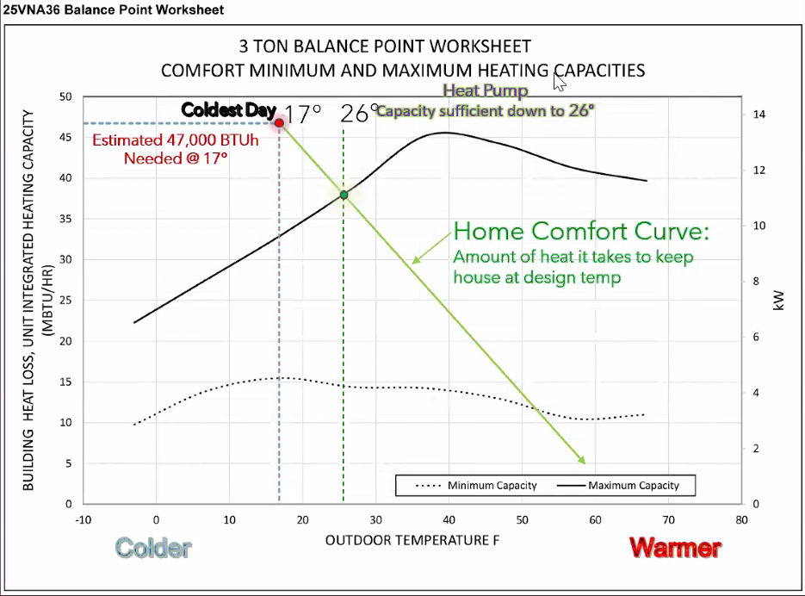

A copy of this fileis saved locally ..\BE\2023-7-12-dual-fuel heat pumps-by-ElectrifyNow.docx- formatted for printing 3/12/2024

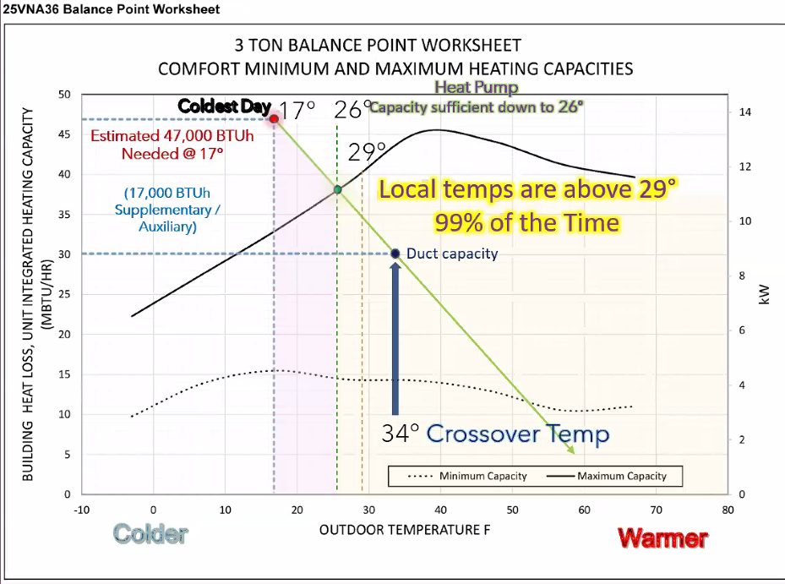

25VNA436 HHP-all Electric-(Full size variable speed HP) vs 25VNA436 HP-Dual Fuel (with communicating furnace)
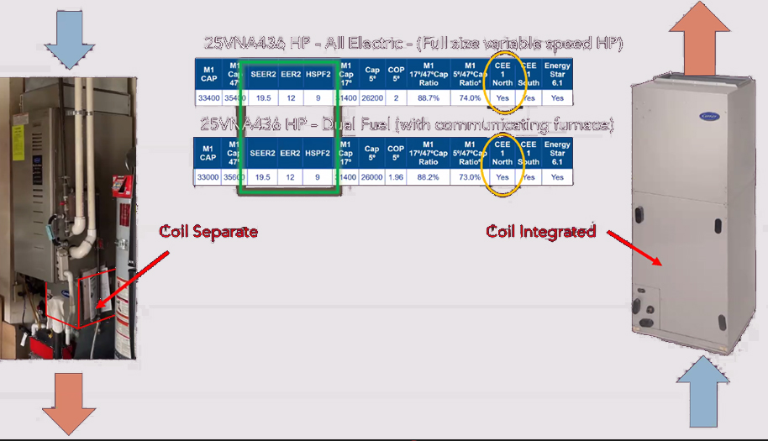
CEE 1 North: YES = qualifies for $2K rebate; Dual fule does NOT qualify, or find one that DOES qualitfy

(This slide re-typed): WHY DUAL FUEL?
It’s still a high performance heat pump system! Using a gas furnace as your air handler could be less work/lower cost
Existing furnace is still operating – less than 5 years old: The furnace could work as an air handler
Furnace + Coil could fit where an Air Handler doesn’t: A furnace can take in air from the side, which offers flexibility in the air handler setup
No room in the Electric Panel: A dual fuel system is a good option if the electric panel is already at capacity
Challenging House/Duct work conditions: High heat from combustion is needed more often in homes wih high heat loads/limited duct capacity
Backup Power: If the home has a generator, it might be sufficient to run the furnace, but not an all-electric heat pump

Following are notes, while speaker is showing slides:
In 2019 occupant switched blower with higher efficiency.
FLLOWING FOR mid-SIZE system: MS= MINISPLIT); 15 SEER HP is single speed
OTHERSIDE: LOWER ROW: FULL SYSTEM REPLACEMENT:; SMALL TO MEDIUM HOUSE: $1500 for backup electric heat electrician
AH = ALL ELECTRIC
LAST ITEM: DUCT IMPROVEMET/CLEANING/SEALING $1-$4K average duct leakage is terrible for heat loss; can blow sealer and get improvement
DOE? is considering raising minimum fossil fuel furnace efficiency from 80% to 95%.
Added cost increase can be high because of venting requirements for PVC
PEOPLE IN THE TRADE NEED TO UNDERSTAND THE NEW TECHNOLOGIES. SEE Q&A
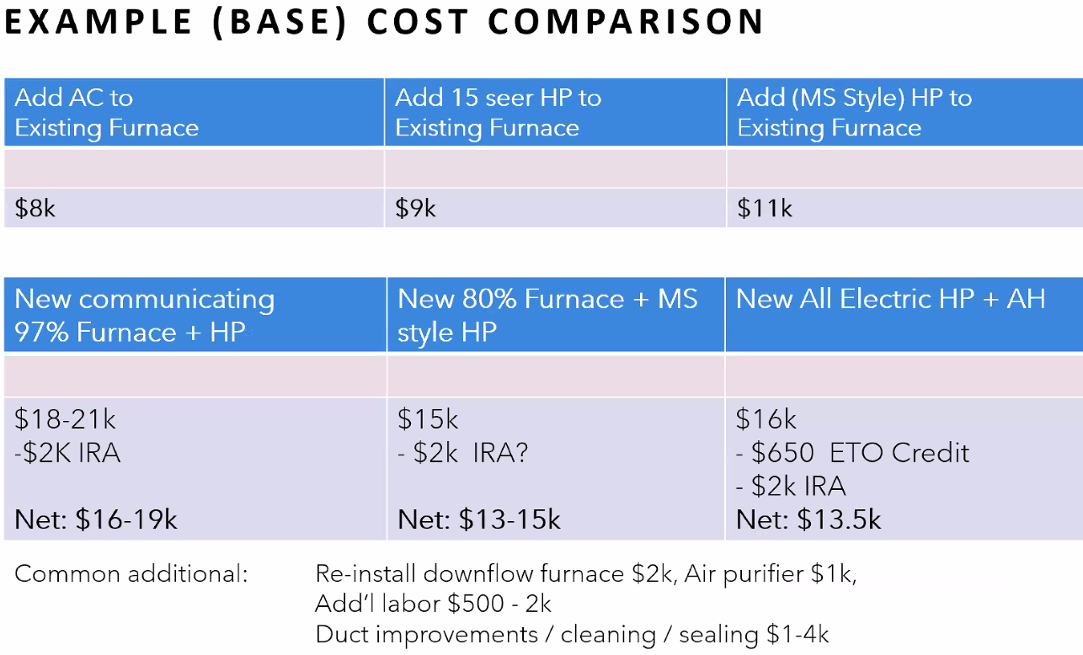
END OF ZACK TURNER’s presentation
Next: THERESA PISTOCHINI, UC DAVIS
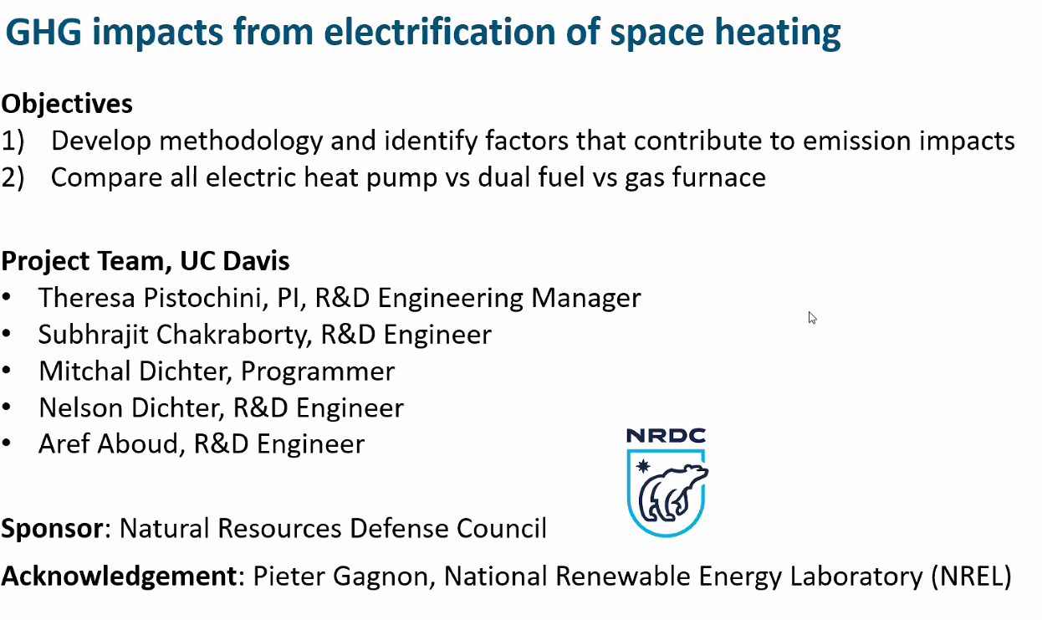
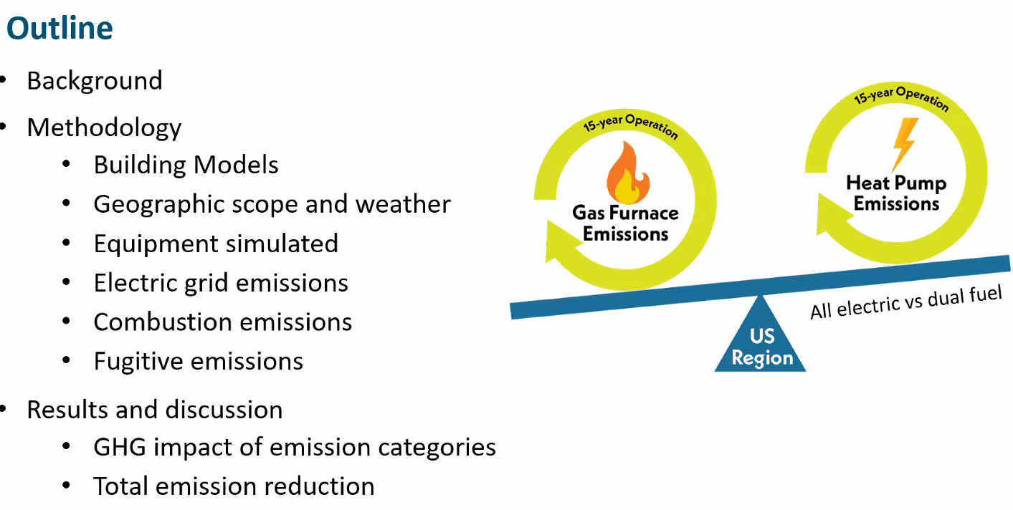
See papers; . This talk looks at allimpacts of dual fuel (not in papers)
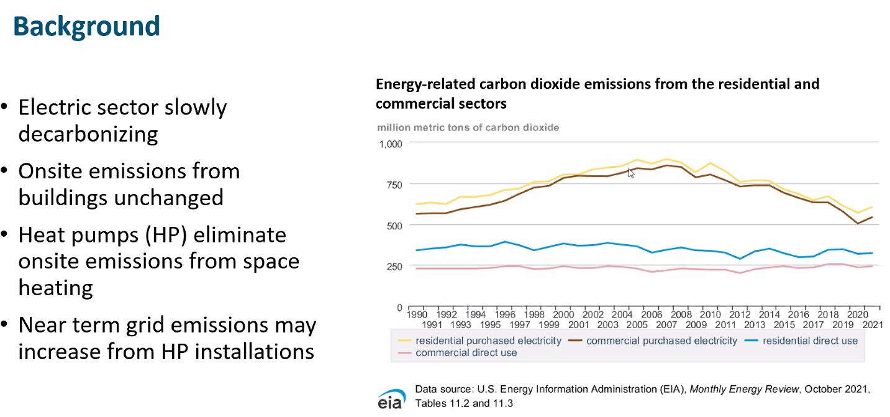
Emissions on-site are stagnant! Need to switch to heat pumps!
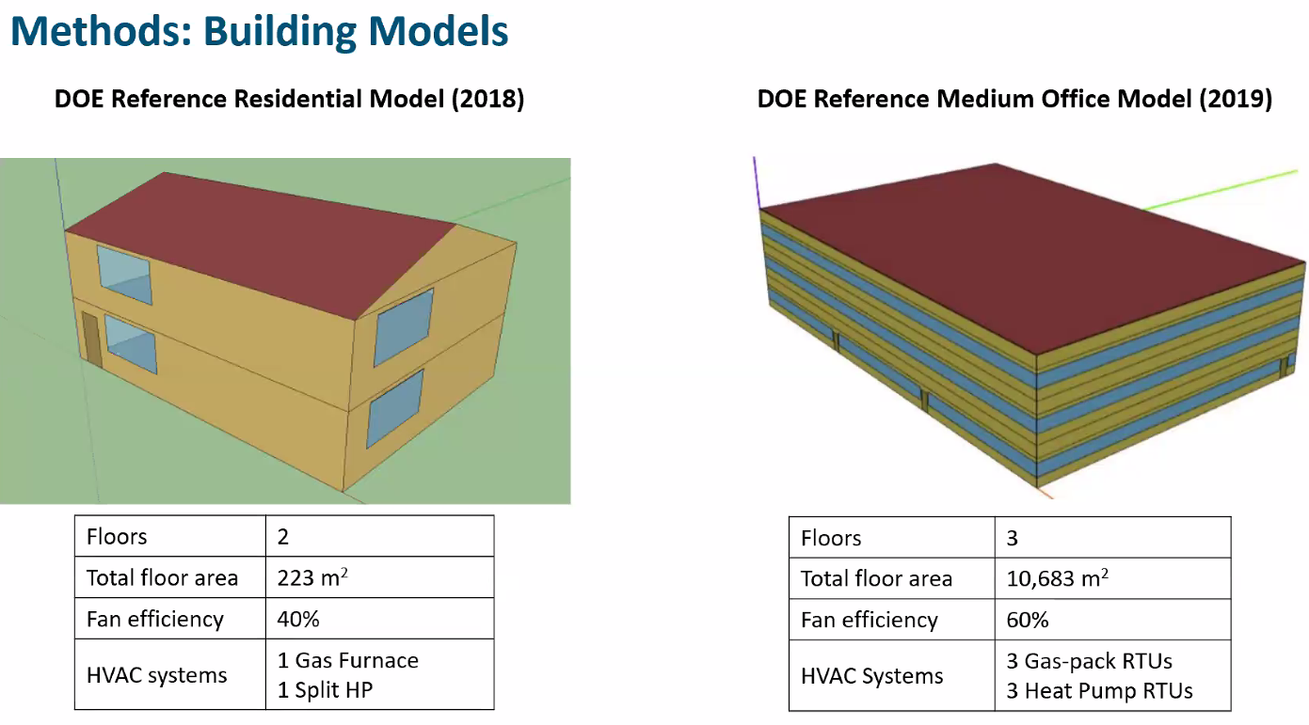
Above are in the papers. Also see additional dual fuel comparison (an adder)
1 square meter is 10.7639 square feet; 223 sq meters is 2400 square feet
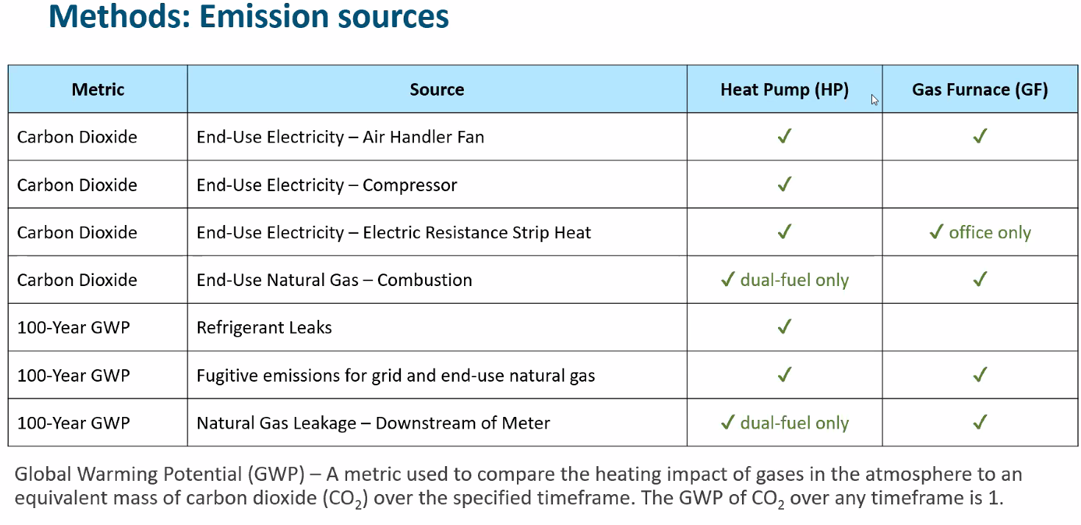
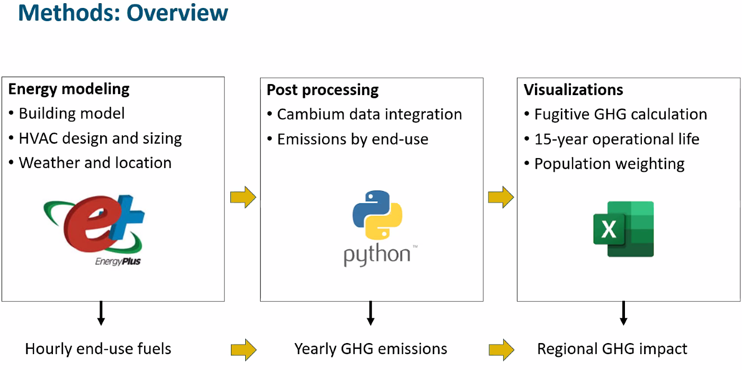
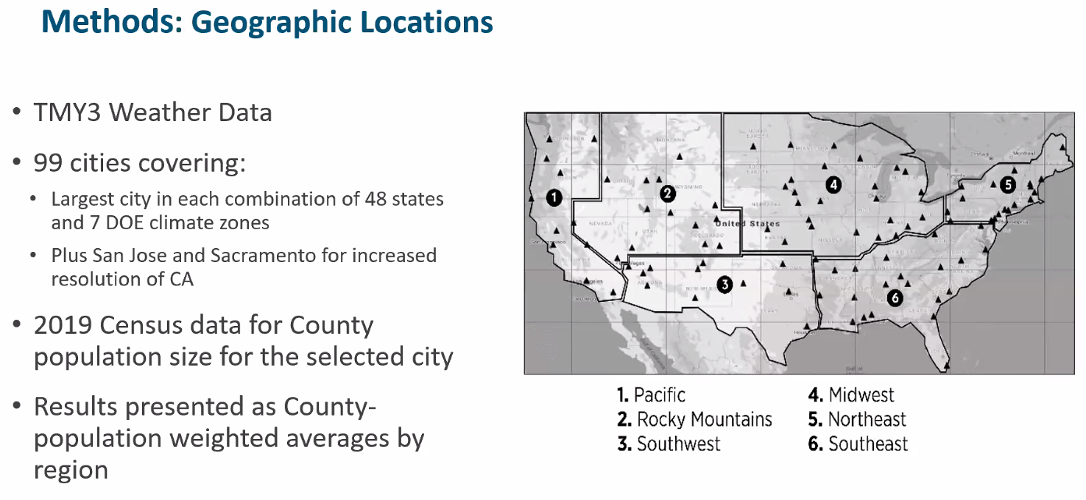
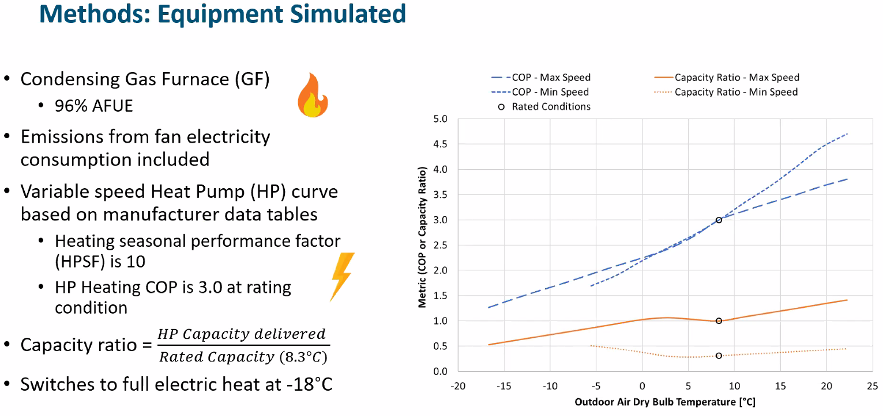
Average variable speed heapump and variable speed furnace
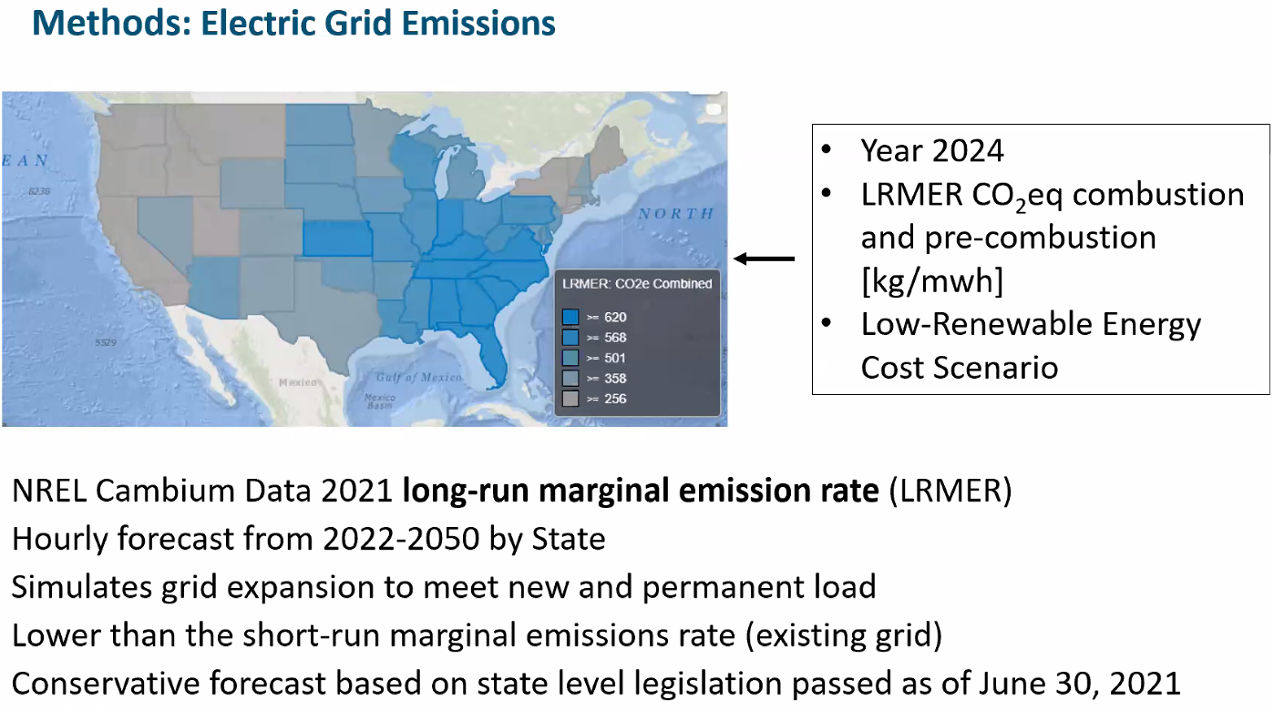
CO2 emissions per mwh generated natural gas is ~400 grams/kwh
FUGITIVE EMISSION: Predicated by end of life. Refreigerant is expected to be more than 100% charge
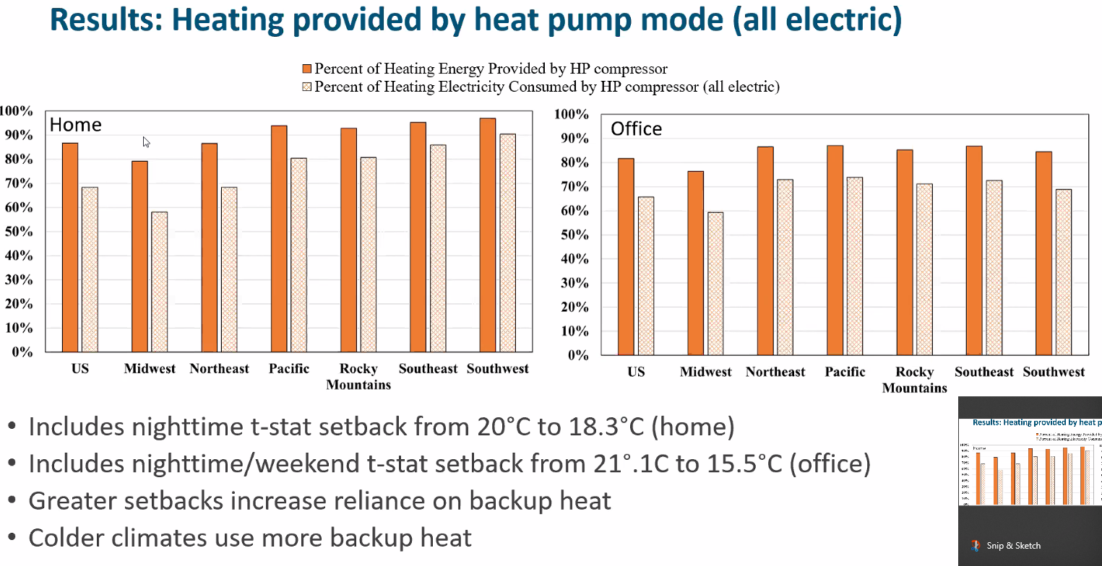
Simulating normal common controls. Nothing fancy. Heatpump operating 5 to 25% of the time.
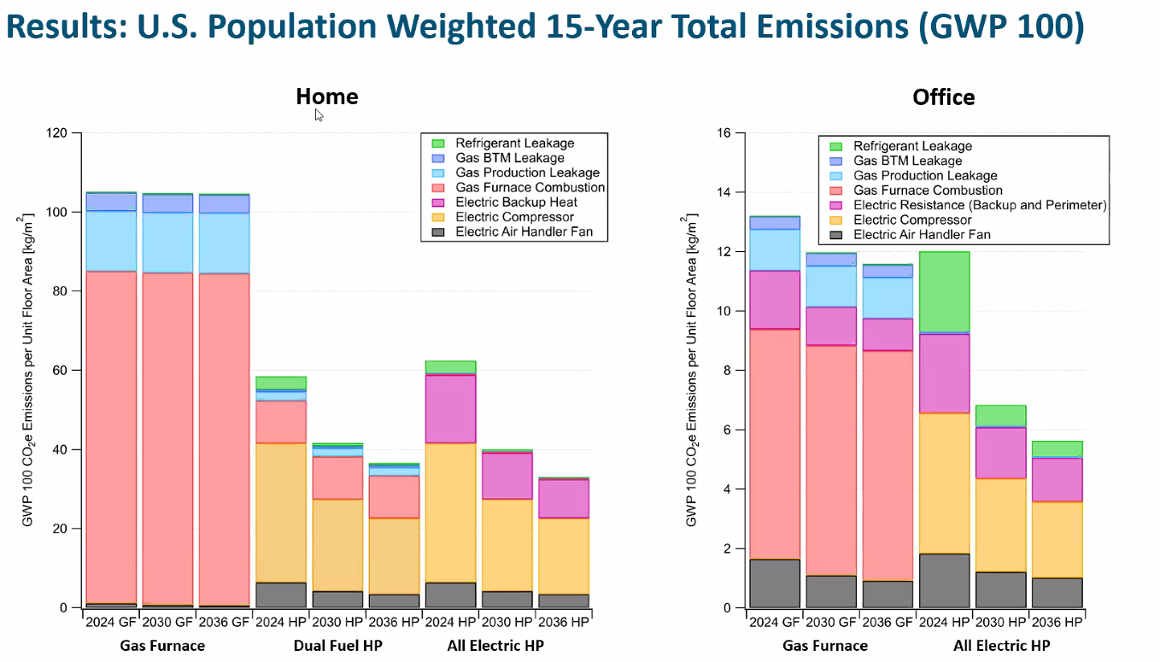
Normalized for floor area.; Simulated standard heat pump; NOT the most highly efficient heat pump!
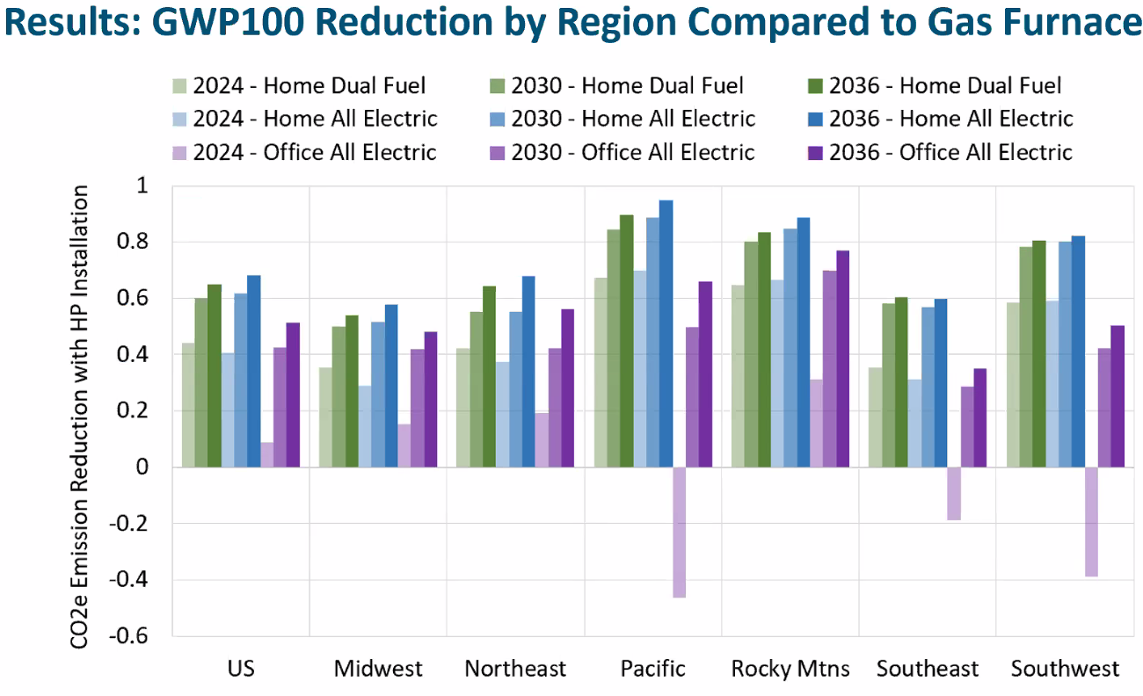
NEGATIVES ARE REFRIGERANT LEAKS WITH MILD CLIMATE!
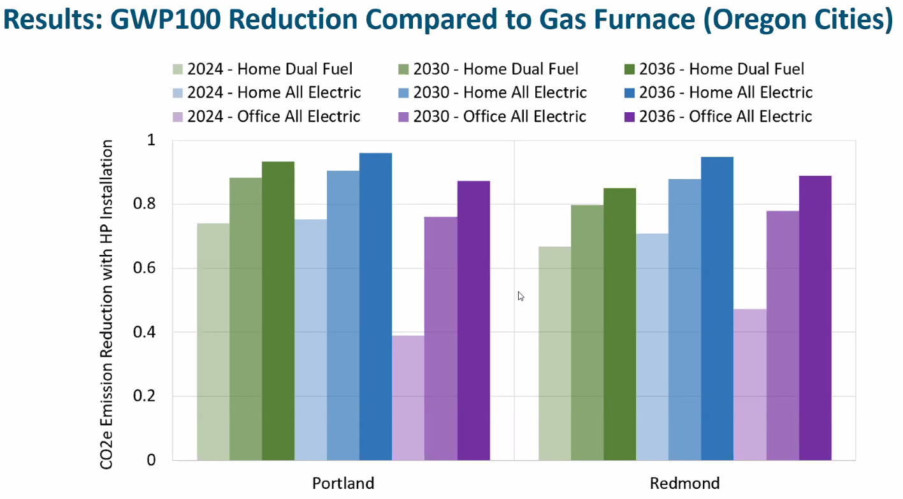
Oregon cities Electric is all electric wind, etc.
Differences between green and blue bar: difference in backup heat. To eliminate need for backup heat- the blue is better

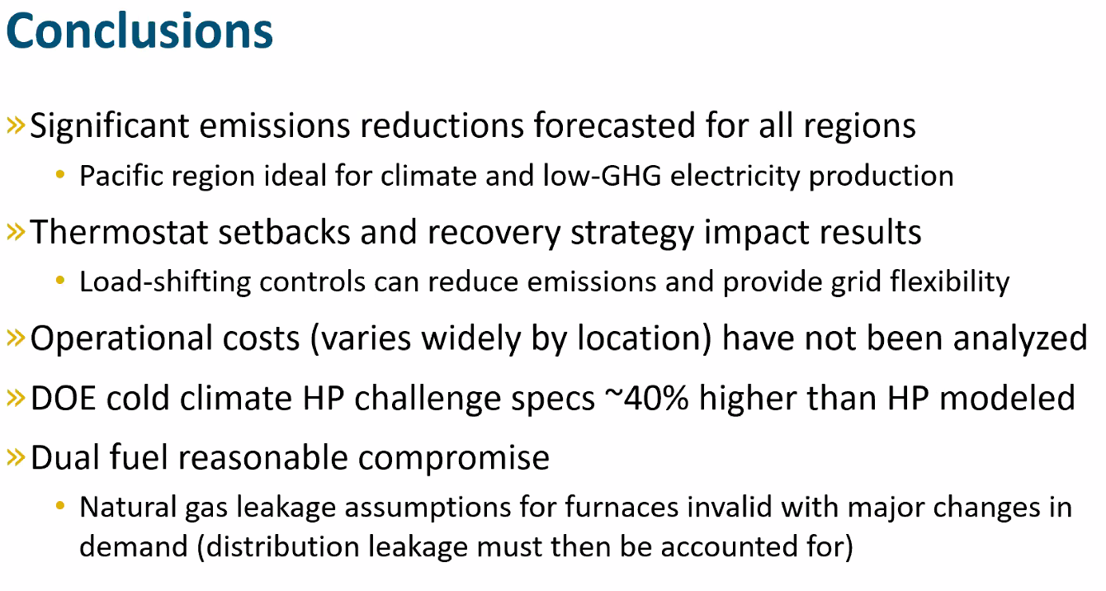
Cold climate heat pump “challenge” is 40% higher specs than HP modeled.
Differences between green and blue bar: difference in backup heat. To eliminate need for backup heat- the blue is better

FOLLOWING IS the “Chat”, and ALSO, at very end:

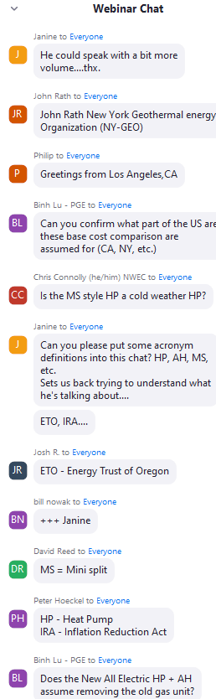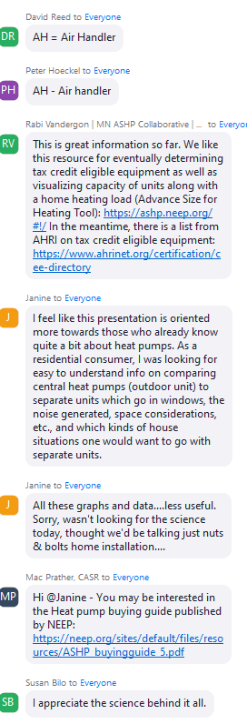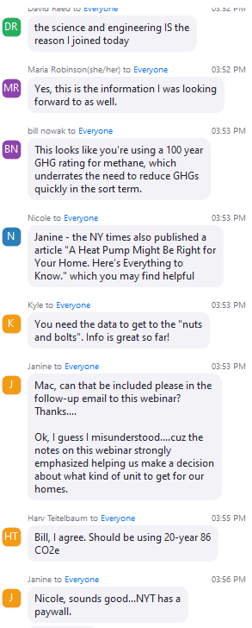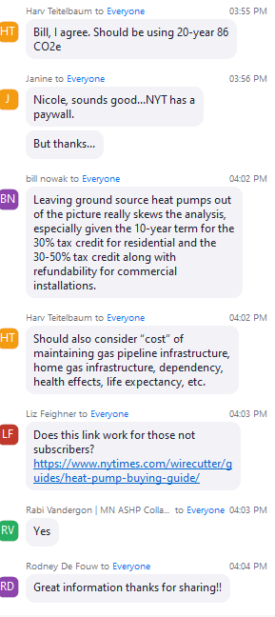
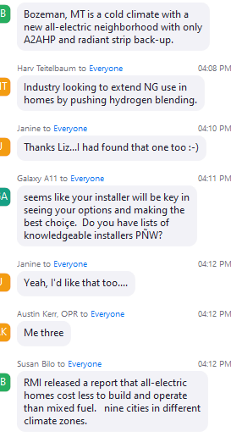
Q&A: Feels electric or furnace has about same operational maintenance costs
Carrier just purchased Toshiba technology patents, etc.
“WATT TIME”. Provides real time data - search Redwood Energy in https://climte.smiller.org/REF

SET POINT TEMPERATURES: If set to 40degrees, squandering
How do we maximize efficiencies of dual fuel system;: the homeowner can ask the lockout where they want it- and the installer can provide the input
Most really good contractors: 40 degrees is OLD SCHOOL don’t want that installer.
Want to get into low 30s. Other customers want to go as ow as they can.
The installer should be listening to homeowner, and should have received consulting up front.
In carrier Bryant network: do the modeling calculations to create exact as can. And use cold climate heat pumps; setting a lockout at 40 degrees is a waste
Zachary Turner, climate control: get system installed; shut off the gas valve, and set thermostat for the system to work in the pump mode. The thermostat will show you what works; that is your Temperature setting for lockout
Wants people to be covered completely with heat pumps; see the diagrams: ducts are a critical component! The equipment will deliver; but other factors will influence home performance . For instance, first perform low hangin fruit- such as insulation, etc
Droop setting, balance point, lock out. A system with gas should to be one of the other for balance point Most manufactures recommend something. Carrier recommends 35 degrees- but this is an approximation. Electric strip is still running; but systems with gas must shut off the heat pump (In a centrally ducted system)
For new construction: Zachary Turner is a residential existing construction person: New construction should be designed such that NO backup needed!
New codes specify insulation and windows: are duct requirements also updated? A huge trend is heat pumps. Cold climate heat pump is the buzz word. Minisplits are huge

